**A) AFFINITY DIAGRAM**

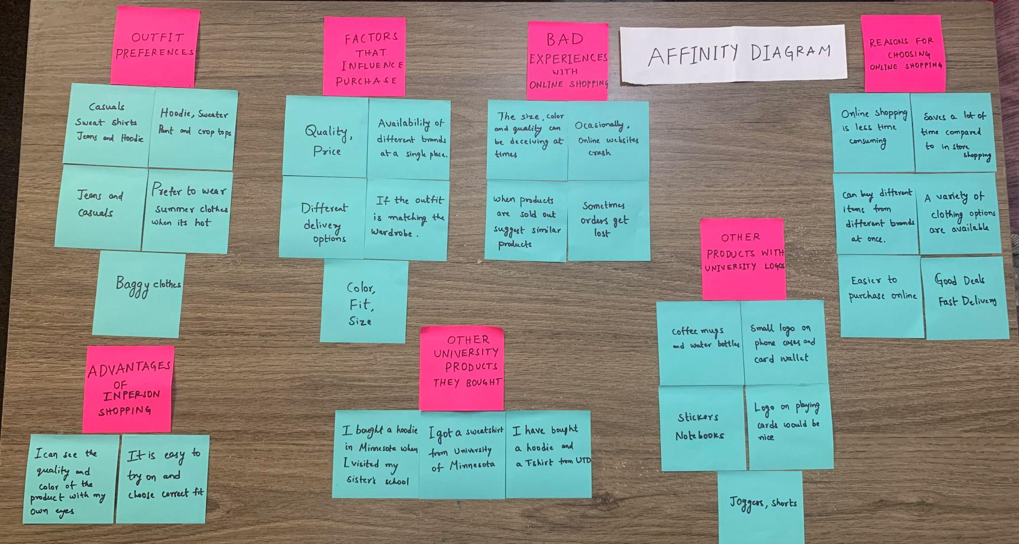

**B) USER NEEDS**

* Fast delivery of the product
* Quality of the product
* Affordable budget range to choose the product
* The appropriate size of the outfits
* Deals and Discount Offers

**C) BREAKDOWNS**

* Late arrival of the product
* Damage to the product
* The product did not live up to the product description on the online shopping platform.
* The products are not sorted based on prices

**D) DESIGN OPPORTUNITIES**

* Perks on late arrivals and damaged product
* Giving a price range feature to set the required prices
* Return/Replace for the products which did not live up to the product description

**E) AFFINITY DIAGRAM THEORY**

**Outfit preferences**

* prefer to wear summer clothes when it's hot
* Hoodie, Sweater, Pants and Crop tops
* Jeans and Casuals
* Baggy clothes
* Casual, Sweat Shirts, Jeans, and Hoodie,

**Factors that influence the purchase**

* Color, Fit, and size
* Quality, and price
* If the outfit is matching my wardrobe
* Different delivery options
* Availability of different brands at a single place

**Reasons for choosing online shopping**

* Online shopping is less time consuming
* It is easier to purchase online.
* A variety of clothing options are available.
* Good deals and On-time delivery
* Can buy different items from different brands at once
* Saves a lot of time compared to in-person shopping

**Bad experiences with online shopping**

* The size quality and color can be deceiving online
* Sometimes the orders get lost
* Occasionally, online websites crash
* When products are sold out, suggest similar products

**Advantages of in-person shopping**

* I can see the quality and color of the product with my own eyes.
* It is easy to try on and choose the correct fit.

**Other products with University logos**

* small logo on phone cases, card wallet
* Logo on playing cards would be nice
* Joggers and Shorts
* Stickers, Notebooks
* Coffee mugs and Water Bottles

**Other University products they bought**

* I got a sweatshirt from University in Minnesota
* I have bought a hoodie and a T-shirt from the University of Texas, Dallas.
* I bought a hoodie in Minnesota when I visited my sister’s school.